Excel Project: Budget Automation

Author: Emily Kokol-Rivera | Date: October 2025 | GitHub: <https://github.com/emilyannKR/excel-portfolio/blob/main/Budget%20Automation/Budget%20Automation.xlsx>

# Project Overview

This project automates monthly budget tracking and analysis using Excel. The dataset includes departmental Budget and Actual values across twelve months, allowing calculation of monthly and total variances. The outcome is an interactive dashboard with KPIs and a dynamic chart that highlights performance trends and automatically updates as new data is added.

# Tools & Skills Demonstrated

* Excel Formulas (SUMIFS, LET, TEXT, MAX, etc.)
* Pivot Tables & Charts (clustered column + variance line)
* Conditional Formatting for positive/negative performance
* Dashboard Design & KPI Card Layout

# Dashboard Snapshot

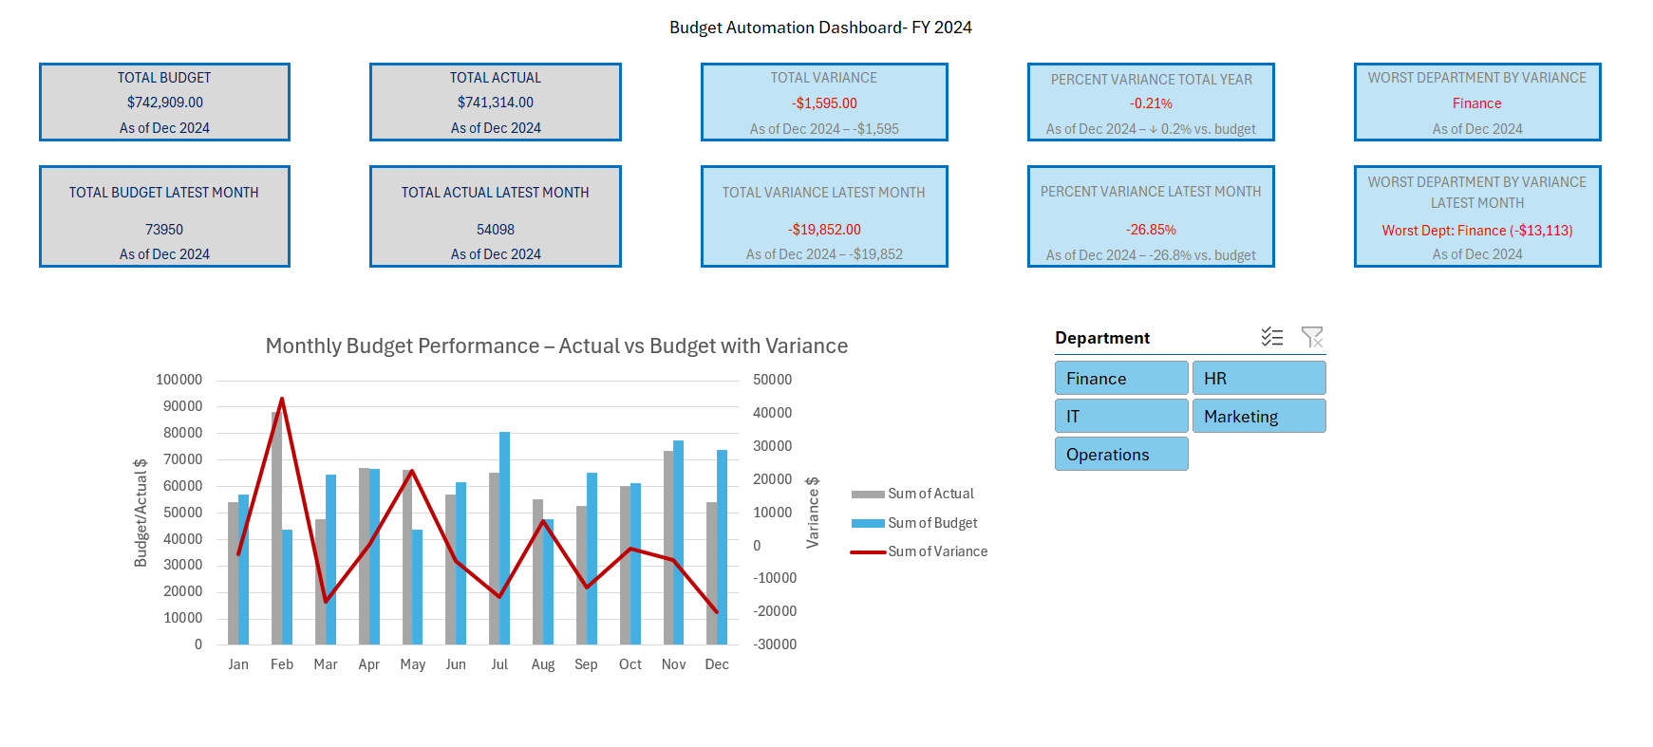

# Key Insights

* Finance showed the largest negative variance in December 2024 (–$13,113).
* Total year variance was minimal (–$1,595), indicating overall budget accuracy.
* Latest-month actuals (December) were 26.8% below budget, signaling a potential year-end spend reduction.